Visualistation Coursework

hnjg78  
Durham University

# Problem 1

## Reasoning Behind Choices

The whole GUI can be seen below:

In the top left is a displacement map of the whole moon surface. There is a helpful color bar at the top indicating the colormap values used to show the displacement. This makes it easy for scientists to quickly see the approximate height of any area of the moon from an elevated angle. As can be seen in the screenshot above, a scientist can drag a box of any size over the map in order to zoom into a particular region of the moon. The selected area is then indicated using a red box on the area of interest.

Once an area has been selected by the scientist to zoom into, 2 maps are rendered underneath. On the left hand side, is a 3D perspective view of the selected area. Then, on the right of this is a flat view of the selected moon surface area. This map shows contours of the selected moon surface, allowing the scientists to analyse the isolines. The 3D perspective displacement map and the contour images are displayed alongside each other so that a scientist can easily compare the two.

By clicking on the flat version of the selected area, a scientist can sample the height of any given point on their area of interest. The point that the scientist clicks on is then indicated by a red point on the map where they clicked, and then the longitude and latitude of the selected point, along with the precise height to 3 decimal places, is supplied just beneath the flat view, as shown in the screenshot below:

The screenshot above shows that a scientist has clicked on the point indicated by the red dot, at longitude 105.167 and latitude 22.5, where the height of the moon surface is 0.235 metres.

Scientists may find that different colourmaps allow them to more easily discriminate between height variations on the moons surface. As such, in the top right of the GUI, there is a dropdown menu that allows a scientist to select one of 6 different colormaps, shown in the screenshot below:

A scientist may also be color blind, and so by providing this functionality, the GUI is capable of being used by someone who may suffer with this disability. The magma colormap is specifically designed so that is can be used by the visually impaired, and as such if someone does have a condition, they can select this colormap, for example.

Once a scientist has chosen a colormap, the GUI renders the maps once again to adapt to this change. For example, if a scientist was to choose the magma colormap, the GUI would change to the following:

In the centre of the GUI, there is a chunk of text that tells the scientist information about the region they are currently viewing.

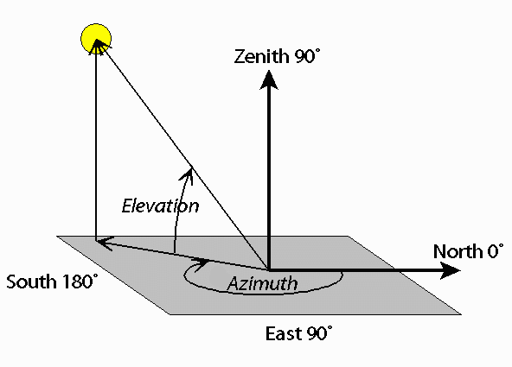The first bit of information tells the scientist the exact area they have chosen to zoom in upon, given by the minimum and maximum longitude and latitude values. The location of the zoomed in region is given in longitude and latitude values, as this is the standard method for scientists investigating locations. Secondly, the view azimuth is given. The view azimuth helps the scientist to change the orientation at which they are viewing their chosen zoomed in surface. Then, the elevation is displayed, which tells the scientist the height at which they are currently viewing their 3D surface. The diagram below shows a visual representation of view azimuth and elevation, courtesy of Celestis Satellite Tracking [1].

At the bottom of the GUI there are 2 input fields. In the first, a scientist can enter their chosen View Azimuth and Elevation, in the format specified in brackets. For example, if a scientist wanted to change their view of the 3D surface to a view azimuth of 120 and an elevation of 60, they would put the following in the input field: [120, 60] and press the button: Change Perspective. For example on the following region, the map would change from the figure on the top, to the figure on the bottom as a result of these actions:

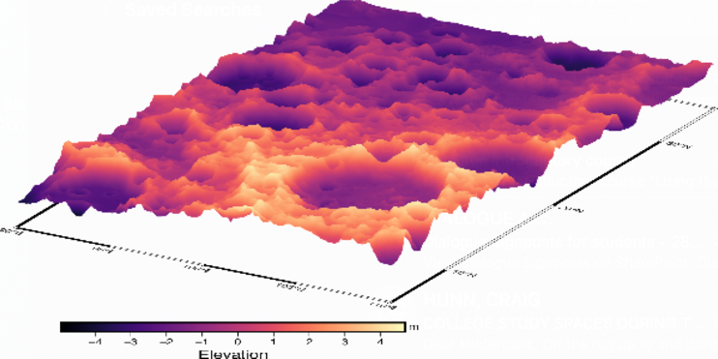

View Azimuth: 150, Elevation: 30

View Azimuth: 120, Elevation: 60

As can be seen in the bottom figure, the 3D perspective has clearly been rotated, and the height of the camera pointing at the moon surface has clearly been elevated to a greater height.

The second input allows the scientist to change the height at which the isocontours are displayed on the flat version of the zoomed in area of the moon’s surface. By default, the height at which isocontours are displayed is every 1 metre of elevation. A scientist can specify any height in order to change this default value. For example, if a scientist wanted to change the height between isocontours to 2 metres, if they thought there were too many isocontours being displayed on the image making it hard to read, then the below top image would change to the second:

Isocontours generated every 1 metre

Isocontours generated every 2 metres

## Advantages and Disadvantages of Each Method

Whole Moon Surface Image

The whole moon surface image allows the scientist to get an overview of the whole surface of the moon so that they can identify specific areas to zoom in upon.

The disadvantages of this are that because the whole moon surface is shown in a fairly small area of the screen, the scientist cannot easily see the change in heights in a more localized area. Additionally, the elevation colours are affected by the highest and lowest areas in the image. As the moon is on the whole a fairly flat surface, most of the moon appears to have the same colour, and so differentiating the heights of the surface in a given area is more difficult.

3D Perspective Displacement Map

The advantage of the 3D perspective displacement image is that it allows the scientist to see a more understandable visualisation of the moon’s surface. This is because a flat displacement map may be hard for the scientist to visualize in their head. However, the 3D perspective displacement map shows the scientist a visualization of the moon that they would see if they were to be just above the moon’s surface looking at it through a camera or with their own eyes. Additionally, as the 3D displacement image is a zoomed in area of the surface, it offsets the issues mentioned previously about the scientist finding it difficult to differentiate heights in more localized areas. Additionally, a scientist’s role is often to present their findings to stakeholders, for example the scientist in charge of finding a suitable landing site may be asked to present his findings to the rest of the Artemis mission personnel. As such, being able to provide a 3D representation of a possible site may be easier to communicate to more non-technical audiences. The 3D perspective map also allows for elevation gradients to be much more visible compared to a flat elevation map as the scientist can clearly see the difference between neighboring points on the surface, as they can be viewed from an angle that is not directly overhead.

3D displacement maps do however have their disadvantages. The first is perspective foreshortening, whereby objects that are further away appear to be smaller. However, in this case, this is less important as the scientist can configure their 3D model to be rotated or zoomed in or out. Another disadvantage of the 3D displacement map is that occlusion can occur. If the scientist selects an area of the surface of the moon with a great range of heights, then depending on the angle at which they are looking at the surface the higher points on the surface may block the scientists view from being able to see the area behind. This could be a problem in particular in craters, whereby the edge of the crater is typically higher than the inside, and so the scientist would have to try and select a potentially very small area from the image at the top of the GUI in order to zoom into the centre of the crater, which may be difficult to perform.

Contour Map

One advantage of the contour map is that it allows the scientist to see which areas of the surface they are investigating are exactly the same height. As the Artemis 3 mission also involves building a base on the surface of the moon, the landing site should ideally be in a location whereby a base can be built nearby. As such, the base may need to have a longer area of flat land, which would mean the contour diagram can be used to see the surface regions with exactly the same height, for example along a contour line. Contour lines are better at showing elevation gradients than the 3D perspective figure. This is because contour lines that are close together clearly indicate a strong height gradient. The contour map also has the added ability to be able to specify the height at which the contour lines are generated. As such, if a scientist wanted to view even very slight changes in elevation, such as 0.25 metres, then this would be possible to visualize. On the other hand, the 3D perspective image does not allow for this customizability.

One of the main disadvantages of the contour map is for when a scientist selects a larger region to analyse. This is because, when the area becomes sufficiently large, the contour line labels can become difficult to see. Additionally, a larger area could mean that there are lots of contour lines visible in the image, and so the information can become cluttered. On the other hand, the scientist could divide this larger area into smaller areas and look at each one in turn, by selecting the smaller areas in the top figure in the GUI one at a time. Another challenge with the contour graph is that contouring ambiguity can occur. As higher-level information such as a topology of the moon’s surface is not available, the contouring is fulfilled at cell-level and as such contouring ambiguity cannot be solved. Another disadvantage of the contour map compared to the 3D perspective map is that it is less useful for comparisons between two surface areas of the moon. This is because, for two different moon surface areas, their contour image may appear very similar or potentially even identical, but their heights may be greatly different, if you did not look at the contour labels. As has been said previously, sometimes these labels can become hard to read and as such this problem emphasized. Scientists may not want to have their landing site on top of a high point or a low point, as it may be difficult to build a lunar base nearby. As such, this is a potential drawback of the contour map compared to the 3D displacement map which, given a sufficiently large area, can easily determine if a given region is notably higher or lower than its surroundings.

# Problem 2

## Reasoning Behind Choices

The designed GUI can be seen below:

At the top of the GUI is the logo for the Artemis 3 mission. Just beneath it is a rotating GIF of the moon’s surface. This animation draws the reader in and makes the public more likely to read the GUI and interact with it, and so more likely to support the cause.

Beneath this is some text that states the main difficulty of the mission, in a way that sounds appealing to the general public. There is then some text encouraging the user to interact with the GUI. This interactivity brings the user’s attention and makes them feel involved in at least some aspect of the mission for themselves. The user is now aware of the difficulty of finding a suitable place to land the Artemis 3 rocket, and now they have the chance to try and find a suitable location for themselves.

Next on the GUI are 2 representations of the moon’s surface. However, unlike the scientific GUI, the general public is not given the option of changing the color map. This was for several reasons. Firstly, the general public most likely does not have much scientific background, and so by adding the option of changing the colors introduces a new level of complexity that could confuse people and distract them from the main focus of the GUI. Additionally, if the color was different to the colors found on the surface of the moon, people could get confused and mistake the moon for another planet or other stellar body. The grayscale color map is suitable for the color blind and is the same color as the moon’s surface, and so is perfect for the general public.

The figure on the left is the complete surface of the moon. The user can then draw a box over it to zoom into a particular area, as in the scientific GUI. However, once a user has selected an area, they can then change the perspective that they view the 3D surface at by using the buttons, shown below:

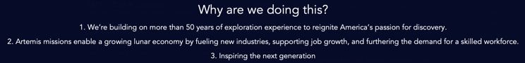This is different to the scientific GUI. A scientist is more likely to want to exactly specify the view azimuth or elevation at which they view the moon’s surface. However, a member of the general public is unlikely to want or need this information, so simplifying this functionality via using 4 simple buttons was used. These buttons allow for the same functionality as the scientific GUI, shown by the screenshots below:

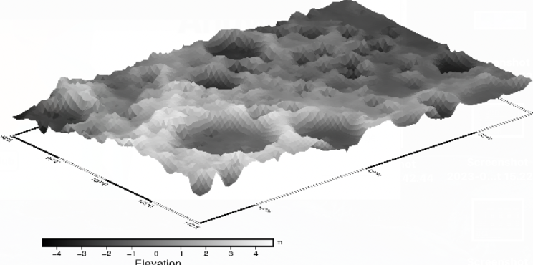

A surface of the moon before the user has pressed any buttons to change the perspective.

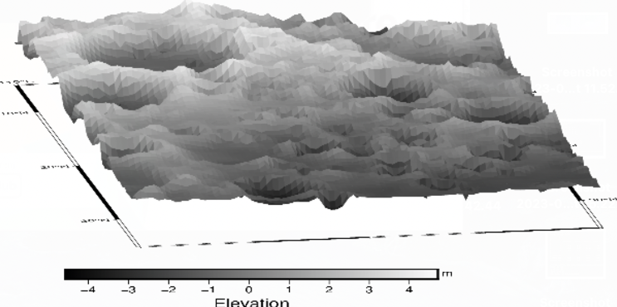

The same lunar surface region, but after the user has used the buttons to change the perspective.

On the far right hand side there is a histogram, an example of info-graphics. This shows the number of potential landing sites at each elevation. The text above challenges the user to try to find some of the landing sites at each of these heights, again to boost engagement. Additionally, it further emphasizes the uneven terrain on the moon in a way that is easy for the general public to understand. The screenshot below shows the histogram on display to the user:

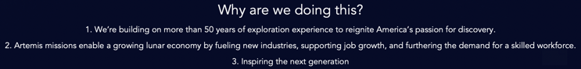At the bottom of the GUI, there is a section explaining to the public the main reasons why the Artemis 3 mission is worthy of the taxpayers money, taken from the NASA Artemis 3 mission website [2]. This is a form of information visualization (a list/borderless table) and gives the general public a clear explanation to justify the mission, as shown below:

The general public GUI is simpler, in order to not overwhelm the user with information, but still providing interactivity to draw the user in, and make them engaged. The colour scheme of the GUI also matches the Artemis 3 mission colours.

##### References

1. <https://www.celestis.com/resources/faq/what-are-the-azimuth-and-elevation-of-a-satellite/>
2. <https://www.nasa.gov/specials/artemis/>